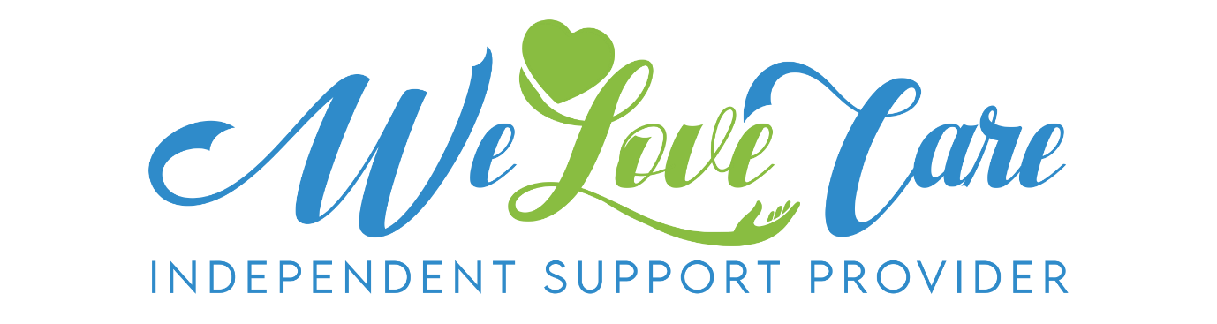

Fee Schedule as of 11/03/2024
 |  | Weekdays  9am-6pm | Saturday  9am-2.00pm | Public  Holidays
Showering |  | $60.00 | $80.00 | $100.00
Social Support  and Community Access |  | $60.00 | $75.00 | N/A
Domestic Assistance |  | $60.00 | N/A | N/A
Larger Seasonal  Tasks |  | $60.00 | N/A | N/A
Meal  Preparation |  | $60.00 | $80.00 | N/A
Gardening |  | $60.00 | N/A | N/A
Personal  Care |  | $60.00 | $80.00 | $100.00
NDIS client fees as per NDIS price guide.

